Instruction for Authors for preparing the Extended Abstract for the 8th IAHR Europe Congress
(14 pt Times New Roman, bold, centred, use “IAHR_title” style)
Name SURNAME¹, Name SURNAME² (10 pt Times New Roman, centred)
¹ Author affiliation (if only one), country (10 pt Times New Roman, centred)
email: name@institution.com (10 pt Times New Roman, centred)
^{2,3} Authors affiliation (if same for a few authors)
email: name@institution.com (for author 2)
email: name@institution.com (for author 3)
Abstract
These instructions are provided to the Authors for preparing of the Extended Abstract to be included in the Book of Abstracts of the 8th IAHR Europe Congress. For writing styles, please refer to Table 1.
Abstracts must be prepared using the template provided and must be submitted in Microsoft Word Document. The Congress and publication language is English, and authors should be sure that the abstract has been written in proper English. No translation facilities will be provided during the event. The maximum length of the extended abstract is two pages A4. This length should allow the authors to provide comprehensive details of their work. The abstract body font is 11-point Times New Roman fully justified. No indentation of the first line of a paragraph. The paper size is A4 (210 x 297 cm) with a 2 cm margin at each side. Lines are single spacing. Author names and affiliations are to be centred and printed in 10-point font. If the co-authors have the same affiliation, type the affiliation ones only. For the abstract text use “IAHR_text” style.
- Heading 1
First-order heading must be numbered with Arabic numbers followed by a comma, bolded, with 0.63 cm text indentation. Use “IAHR_heading1” style.
  - Heading 2
Second-order heading has to be numbered with two Arabic numbers followed by a comma, italics. Use “IAHR_heading2” style.
Equations should be numbered consecutively. The equation number is to be placed at the right side as shown in Eq. (1). Refer to the equation by this number. When referred to in the text, the equation should be cited as Eq. (1), Eqs. (3)-(5); if the word “Equation” begins a sentence, it should be written out in full. Indent each equation by 1.5 cm. Use “IAHR_equation” style. Example equation:
(1)
where t – time [s], T(x, t) – time-averaged water temperature [°C], x = (x, y, z) – position vector [m], x – longitudinal coordinate [m], y – transversal coordinate [m], z – vertical coordinate [m], v(x) = (v_{x}, v_{y}, v_{z}) – time-averaged velocity vector [m s⁻¹], D_{M}(x) – molecular heat diffusion tensor [m² s⁻¹], D_{T}(x) – turbulent heat diffusion tensor [m² s⁻¹], Q – source function describing additional heating or cooling processes. Please note the use of SI units is mandatory; all units should be displayed using exponential formatting and typeset using normal font (not italic or bold); multiplication of units should be indicated by a space and division by negative exponents (e.g. m s^{–2}); common, explicitly defined, functions should not be italic (e.g. Γ(y) for the gamma function, exp(a + b), sin(x)); mathematical operators and constants should not be italic (e.g. dx, e = 2.718…); vectors and matrices and tensors should be bold (e.g. x = (x, y, z) – position vector, D – diffusion tensor); symbol for the decimal marker is the dot.
Figures should be of good quality. Please use fonts large enough to be readable. Captions should be in 8.5-points, centered font, numbered with Arabic numbers. For example, see Fig.1. All figures must be cited in the text. When referred to in the text, figure should be cited as Fig. 1, Figs. 3-5; if the word “Figure” begins a sentence, it should be written out in full.
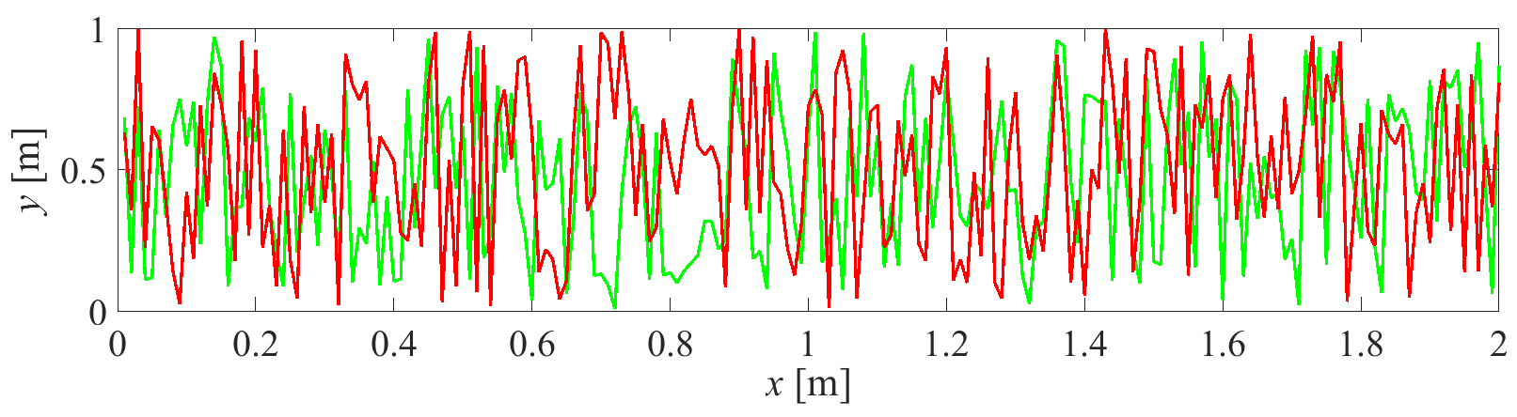
Fig. 1. All captions should be placed below the figure. Please use graphics fonts large enough to be clearly readable. Figures captions should be 8.5 pt. Times New Roman, centred, numbered with Arabic numbers. Use “IAHR_figure_caption” style.
Tables should be numbered with Arabic numbers. Table’s number and the title should be placed on top of each table. Units should be indicated. Table number, title and table text are to be in 9-point, centered font. Tables are to be centered. See for example Table 1.
Table 1. Formatting rules
Object | Style | Font | Alignment | Space above | Space below
Header | IAHR_header | 10pt | centered | 0pt | 0pt
Title | IAHR_title | 14pt bold | centered | 30 pt | 12pt
Author(s) | IAHR_author | 10pt | centered | 0pt | 6pt
Affiliation | IAHR_affiliation | 10pt | centered | 6pt | 0pt
Addresses | IAHR_address | 10pt | centered | 0pt | 0pt
ABSTRACT wording | IAHR_abstract | 11pt | centered | 24pt | 6pt
Abstract text | IAHR_text | 11pt | justified | 6pt | 0pt
Heading1 | IAHR_heading1 | 11pt bold | justified | 6pt | 0pt
Heading2 | IAHR_heading2 | 11pt italics | justified | 6pt | 0pt
Table number | IAHR_table_no | 9pt | centered | 6pt | 0pt
Table title | IAHR_table_title | 9pt | centered | 0pt | 6pt
Table text | IAHR_table_text | 9pt | centered | 0pt | 0pt
Figure captions | IAHR_figure_caption | 8.5pt | centered | 3pt | 0pt
Equation | IAHR_equation | 11pt | left | 6pt | 0pt
Equation captions | IAHR_equation_captions | 10pt | left | 3pt | 0pt
Acknowledgements’ title | IAHR_ackn_title | 9 pt bold | left | 6pt | 0pt
Acknowledgements | IAHR_ackn_text | 9 pt | justified | 6pt | 0pt
References list title | IAHR_references_title | 9pt bold | left | 6pt | 6pt
References | IAHR_references | 9pt | justified | 6pt | 0pt
All tables must be cited in the text. When referred to in the text, the word “Table” should be written out in full. Leave the blank space next to a table.
References in the text should consist of the Author’s surname followed by a year of publication in parentheses, e.g. (Bullen, 1985). If more than two authors, please give the first author’s name followed by “et al.” and year, e.g. (Smith et al., 2005). All references cited in the text must be included in the reference list at the end of the paper. Use the word “References” as the title of the reference list, 9-point, bold, font (“IAHR_references_title” style). The references are to be in 9-points font. This is done automatically when you enter the reference using the “IAHR_references” style. References should appear in alphabetical order at the end of the paper.
The Abstract should be prepared according to the instruction and must be submitted using the link sent in the registration confirmation e-mail and following the submission guidelines. Other forms of submission, e.g., by post, email or fax cannot be accepted.
Acknowledgements
Acknowledgements may appear before the list of references. Use the word “Acknowledgments” as the title, 9-point bold, left-justified font (“IAHR_ackn_title”). The acknowledgement text is to be in 9-points font (“IAHR_ackn_text”).
References
Bullen KE, Bolt BA (1985) An Introduction to the Theory of Seismology, Cambridge, 400 pp. (in the case of a book)
Mrokowska MM, Rowiński PM, Kalinowska MB (2015) A methodological approach of estimating resistance to flow under unsteady flow conditions, Hydrology and Earth System Sciences, 19, 4041-4053 (in the case of a journal article)

